Trinity College Writing Center
Coordinator Manual

Table of Contents
About the Writing Center 2
Mission of the Writing Center 2
Dates and Hours of Operation 2
Daily Responsibilities 2
Greeting Students in the Writing Center 3
Creating an Account for a Student 3
Scheduling an Appointment for a Student 4
Appointment Summary Forms 6
Entering Information to the Client Report Form 7
Walk-In Appointments 10
Missed Appointments 11
Scheduling of the Coordinators 11
Reporting time worked in TCOnline 11

Trinity College Writing Center
115 Vernon Street
Hartford, CT 06106

Coordinator Manual

About the Writing Center
The goal of the Writing Center is to help improve student’s writing as a whole. Writing Associates work with students in a variety of ways, including discussing an assignment, reading an assignment aloud, and brainstorming ideas to start or continue an assignment. Writing Associates do not proofread or make copy edits, but instead look for patterns of error to work with students on punctuation.

Mission of the Writing Center
We work with students at all stages of the writing process to develop their confidence and abilities as writers. We are committed to fostering a community of inclusion, diversity, and equity through which we believe we all become better students and writers.

Dates and Hours of Operation
- Hours of operation are as follows:
  - Sunday 7:00 – 10:00 p.m.
  - Monday 3:00 – 10:00 p.m.
  - Tuesday 3:00 – 10:00 p.m.
  - Wednesday 3:00 – 10:00 p.m.
  - Thursday 3:00 – 10:00 p.m.
  - Friday – Closed
  - Saturday – Closed
- The Writing Center opens the 2nd week of classes during both the fall and spring semesters.

Daily Responsibilities
- Opening:
  - Separate tables
  - Open blinds
  - Complete paper Appointment Summary Forms for first appointments
  - Tidy up the room
  - Set out coffee supplies and candy bowl
- Closing:
  - Move tables back to conference table configuration
  - Tidy up the room
  - Return coffee supplies and candy bowl to book shelf cabinet

- Usual Tasks:
  - Complete the appointment summary sheets before the scheduled appointments, either at the start of the shift or before each hour/half-hour appointment.
  - Keep the printer stocked with paper (located in the file cabinet to the right of the printer.)

Greeting Students in the Writing Center
- Greet all students as they enter the Writing Center. This can vary from a simple “hello” to “welcome to the Writing Center.”
- Once greeted, students should be asked, “how can I help you?” Students may be visiting to attend a tutoring session, ask a question, make an appointment, or study hall.

Creating an Account for a Student
All Writing Center employees have administrative access to mywconline, the Writing Center’s online scheduling system. Following are the steps to create a student account:

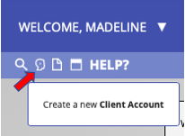
- On the main screen of mywconline, click the small button that is a profile of a head to “Create a new Client Account” as shown below.

- Enter each student’s information correctly. The student’s email address should be their Trinity email address, unless the student is from a Hartford public school.
- Be sure the “Notify client” box is selected so the student receives an email.
- The student is welcome to enter their own password, or the automatically generated ten-digit number can be used and the student can change the password at a later time.
- Click the “Create Account” button at the bottom left of the screen once the student’s information is entered completely and correctly.

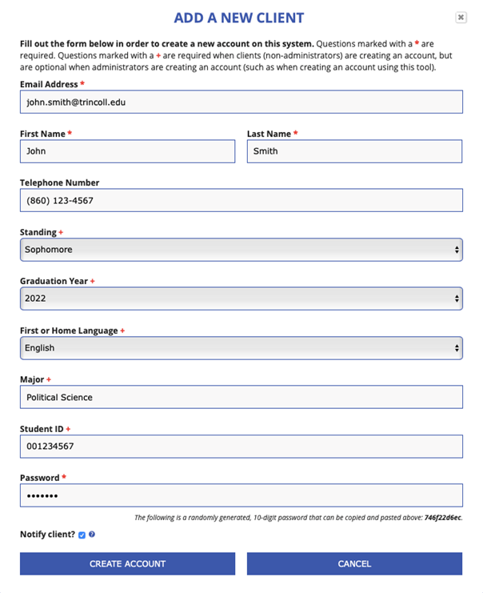

Scheduling an Appointment for a Student
- Appointments can be created and deleted for any student that already has an account.
- Students can schedule appointments for later dates when they are visiting the Writing Center; frequently students will visit the Writing Center just to have the Coordinator schedule an appointment for them.
- A white box on the schedule indicates an open appointment, while a blue box indicates a scheduled appointment.
- To create a new appointment, click on a white box. The following screen will open:
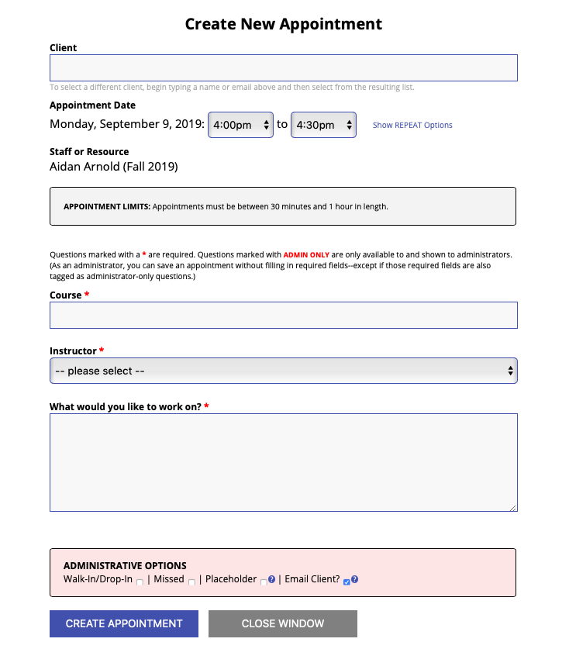

- Complete the required fields and click “create appointment.” An email will be automatically generated and sent to the student with the appointment information.
- Individual appointments can be viewed on mywconline by clicking the box on the schedule. To display the name of the student scheduled for an appointment, hover the mouse over an appointment box.
  - For example, clicking on this box will show the appointment scheduled from 7:00-7:30 with Bonnie.

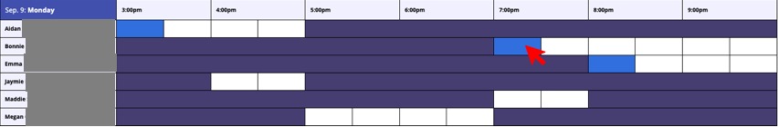

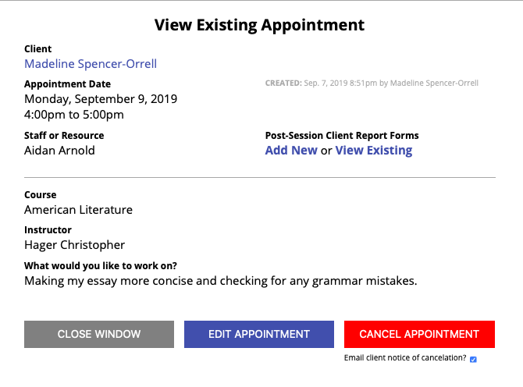
- Once an appointment is selected, it can be deleted or “cancelled” by clicking the red “cancel appointment” button at the bottom of the window.

Appointment Summary Forms
- Prior to the appointment, the top section of the Appointment Summary Form is completed by the Coordinator with the information provided by the student on mywconline.

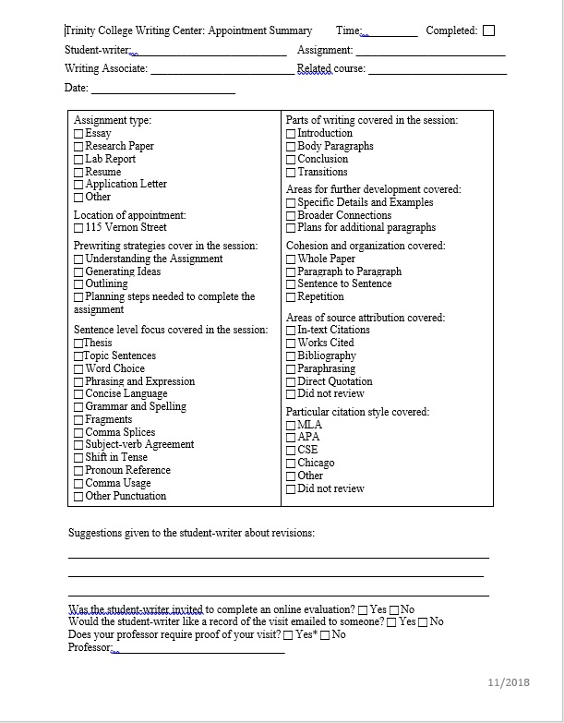

- The paper Appointment Summary Form is handed to the Writing Associate who will be working with the student. The Writing Associate will complete the remainder of the Summary Report and will return the paper copy to the Coordinator to enter the information into mywconline.

Entering Information to the Client Report Form
- Transfer the information from the paper copy of the Appointment Summary Form to the electronic Client Report Form.
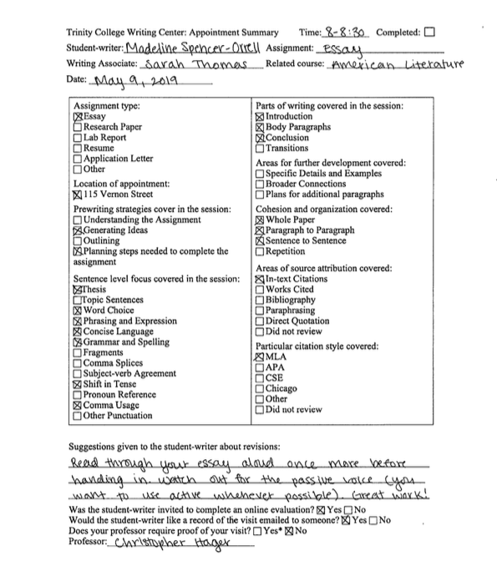
- Click the “Add New or View Existing” button to transfer the information to the electronic Client Report Form.

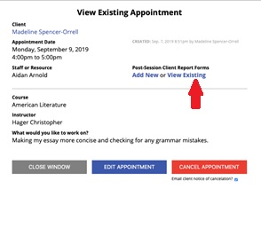

- For the above paper Appointment Summary Form, the following images show what the electronic Client Report Form would look like:

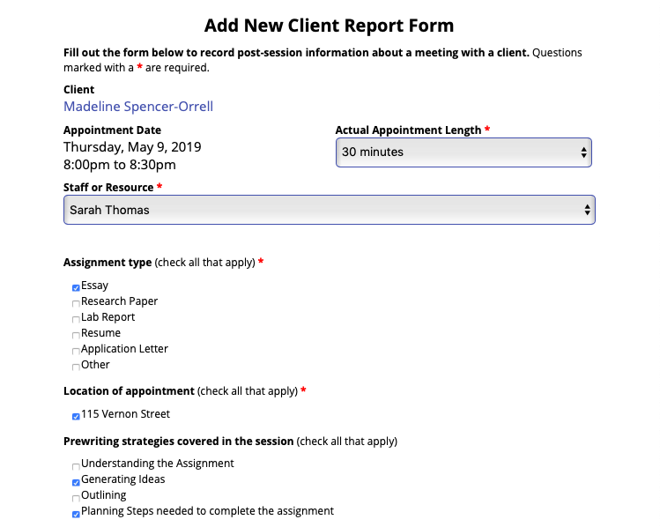
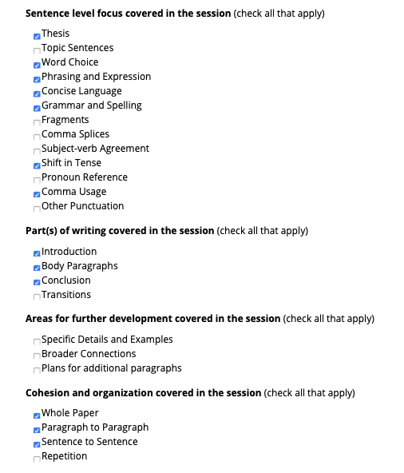
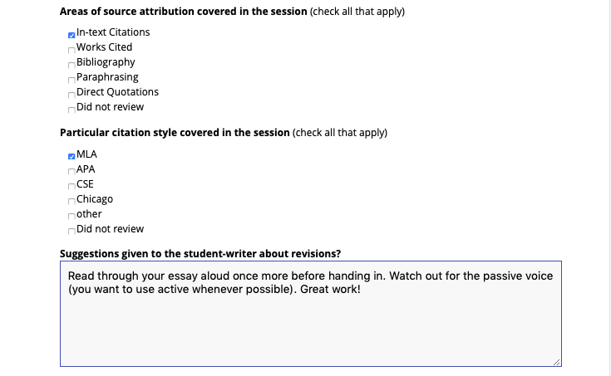
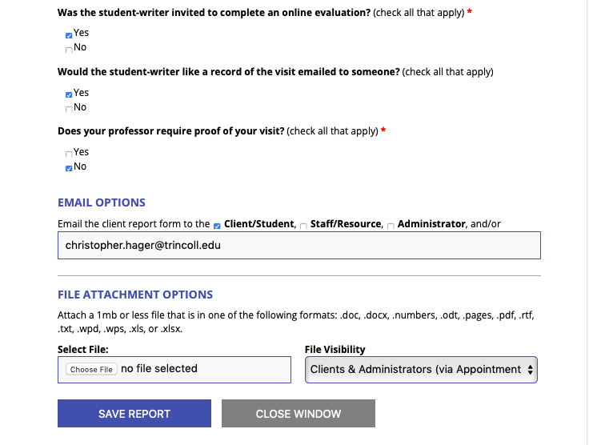
- Notes:
  - The “Actual Appointment Length” is automatically recorded for the length the appointment was scheduled for. If the appointment runs shorter or longer than the scheduled appointment, edit the actual time by clicking on the “Actual Appointment Length” drop drown arrow.
  - The “Staff or Resource” for the original appointment will automatically be the Writing Associate who was scheduled for the shift. If a different Writing Associate is covering during this shift, or if the appointment was shifted to another Writing Associate, use the drop down arrow to change the name of the Writing Associate.
  - “File Visibility” automatically selects “Administrators Only”. Use the drop down menu to change this to “Clients & Administrators (via Appointment Form).”

Walk-In Appointments
- Walk-in appointments are scheduled based on Writing Associate availability.
- To create a Walk-In Appointment, the same steps are followed for creating any appointment—but before “create appointment” is clicked, the “Walk-In/Drop-In” box should be selected as shown below.
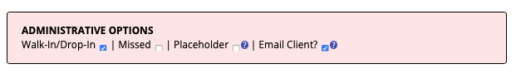
- Once this box is selected, click “Create Appointment.”

Missed Appointments
- If a student misses an appointment, mark the appointment as “Missed,” rather than cancelling the appointment. Appointments should be marked “Missed” 5 minutes into a 30-minute appointment and 10 minutes into a 60-minute appointment.

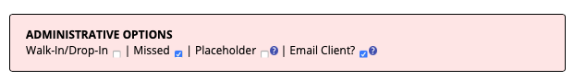

- If a student misses two appointments, their account will automatically be disabled and they will no longer have the ability to schedule their own appointments. In order for a student to regain scheduling privileges, they must email or meet with either the Director or Administrative Assistant of the Writing Center to have their account enabled.
- To mark an appointment as “Missed,” click the “Edit Appointment” button. At the bottom of the screen, select the “Missed” box as shown below. Once selected, click the “Save Changes” button. The scheduling system will automatically remove the appointment from the schedule. A system generated email will notify the student of the missed appointment and disabled account.

Scheduling Coordinators
- At the start of each semester, the Administrative Assistant for the Writing Center will collect staff members’ availability for the semester to create a schedule for both Coordinators and Writing Associates. It is important to respond promptly to any scheduling emails with times you are available.
- Communicating with colleagues
  - The Writing Center uses the app GroupMe for all Writing Center employees to stay in touch. GroupMe can be downloaded for free from the App Store or the Play Store on smartphones or tablet devices. GroupMe can also be accessed online at groupme.com.
- Missing/covering a shift
  - Typically, GroupMe is used when looking for coverage for a shift.
  - A message asking for coverage often looks like: “Hey! I have a conflict (i.e. sports game, dinner, meeting, etc.) on Tuesday 10/15 for my 5-7 shift. Can anyone cover it for me please?”
  - When another coordinator responds saying they can cover the shift, email the Administrative Assistant to notify them of the coverage change. Include information about date, time, and person covering the shift. The staff member covering the shift should be copied on the email.

Reporting time worked in TCOnline
- Time worked must be recorded on TCOnline; http://tconline.trincoll.edu
- To enter time: Self Service>Time Reporting>Report Time>Timesheet.
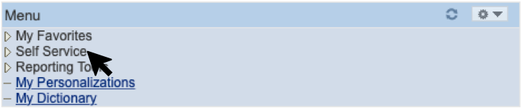
- The following screenshots demonstrate the steps to submitting a time sheet:
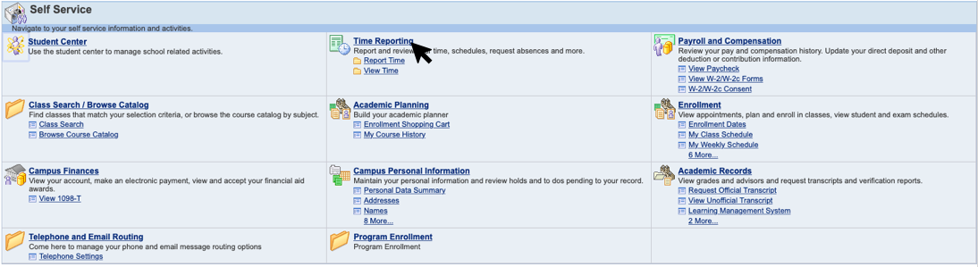
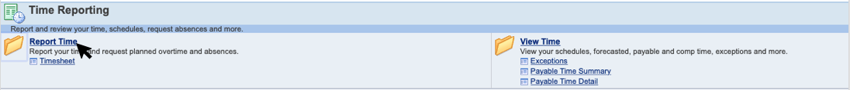
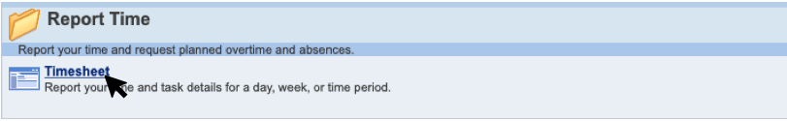

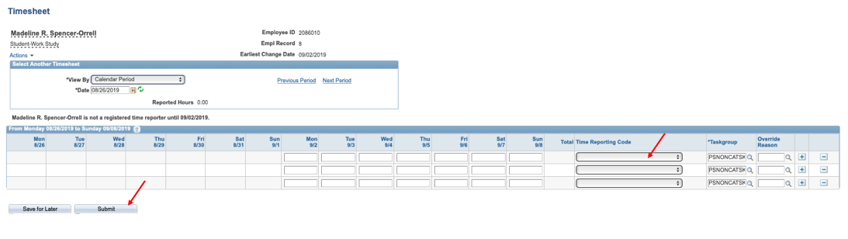
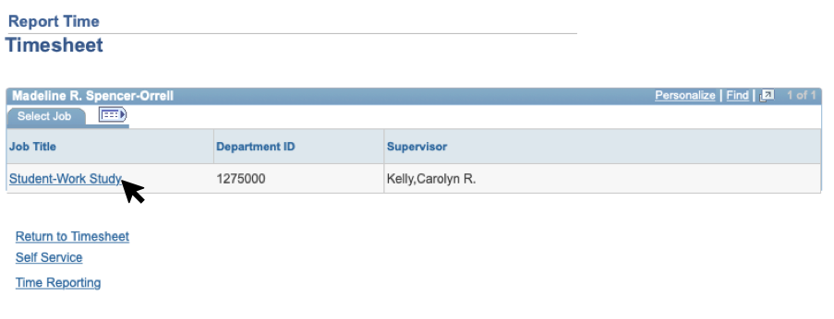

- Once you have entered hours worked during the time-period, the “Time Reporting Code” must be selected. Click the drop down arrow to choose either RSS (Regular Non Work Study) or RWS (Regular Pay for Work Study).
- Click either “Save for Later” to continue adding hours throughout the period or “Submit” to submit the timesheet for approval.

