Travelers Risk Control
350 Granite Street
Braintree, MA 02184

January 6, 2016
Mr. Claudio Bazzan
Executive Director Facilities
City Of Hartford - Martin Luther King School
25 Ridgefield St
Hartford, CT 06112

Dear Mr. Bazzan:

I would like to thank Patrick for taking the time to meet with me on January 4, 2016. This letter summarizes my visit and our discussions.

RECOMMENDATIONS

The following recommendations are offered to help you in your efforts to improve your current safety program and help reduce your potential losses.

Recommendations that are categorized as “JURISDICTIONAL” require a written response within 30 days of this survey. Jurisdictional recommendations address conditions that are in violation of the jurisdictional code and a certificate of inspection cannot be approved.

Jurisdictional Construction Permits Internal Inspection
Date Found: 1/4/2016
Status: Open
Object Number | Manufacturer | Type | Year Built | Object Location
Both | Bigelow Co. | Boiler | 1922 | Blrm
The boiler construction permits internal inspection which should be completed prior to the next biennial certificate expiration. Please contact our office to schedule the internal inspection. Reference: https://www.cga.ct.gov/current/pub/chap_540.htm , Chapter 540 Boilers and Water Heaters, Sec. 29-237. (Formerly Sec. 19-434). Inspection (3)
IMPORTANT - Immediately Discontinue Use - Corrosion Noted on Boiler
Date Found: 1/4/2016
Status: Open
Object Number | Manufacturer | Type | Year Built | Object Location
002062 | Bigelow Co. | Boiler | 1922 | Blrm
1/4/2016 Severe metal corrosion was observed around the top manhole while the boiler was running. 11/12/2013 One of the Bigelow heating boilers (002062) at the Martin Luther King School was noted to be heavily corroded around the top manhole cover. It is suspected that the steel has wasted significantly in this area on the top of the boiler. An internal inspection of both heating boilers in operation here is requested after the heating season is over. The issuance of the boiler operating certificates will be contingent on the condition of the boilers as determined by the internal inspections after the heating season. Please contact me regarding setting up this internal inspection.
Associated Hot Water Tank - Temperature-Pressure (T&P) Relief Valve - Leaking
Date Found: 1/4/2016
Status: Open
Object Number | Manufacturer | Type | Year Built | Object Location
102089 | AO SMITH | Boiler | 2008 | DAY CARE
The T&P relief valve lifting cause should be determined and addressed and/or this valve should be replaced. The new valve shall be an ASME/NB-stamped T&P relief valve set to relieve at or below 210 deg. F with a set pressure not exceeding the tanks maximum allowable working pressure and a minimum relieving capacity required for the hot-water system should be installed to meet jurisdictional code requirements.

Jurisdictional ASME Data Nameplate - Not Located - Identify to Inspector
Date Found: 1/4/2016
Status: Open
Object Number | Manufacturer | Type | Year Built | Object Location
All | Bigelow Co. | Boiler | 1922 | Blrm
The ASME Code nameplate was not located. This information may be stamped on the front head. Please locate & expose the boiler ASME date nameplate so that required code information can be verified. This information should be made available to the Jurisdictional Inspector for review.

Rear Observation Ports - Restore Usability
Date Found: 1/4/2016
Status: Open
Object Number | Manufacturer | Type | Year Built | Object Location
002061 | Bigelow Co. | Boiler | 1922 | Blrm
Non-usable port glasses may be an indication of a combustion issue. Observation ports shall be provided to permit direct visual inspection of the pilot, main burner flame, and boiler furnace. Reference ASME CSD-1 Part CG General - CG-230 Observation Ports

Jurisdictional Relief Valves - Excessive and/or Inconsistent Set Pressures
Date Found: 1/4/2016
Status: Open
Object Number | Manufacturer | Type | Year Built | Object Location
002062 | Bigelow Co. | Boiler | 1922 | Blrm
Two relief valves were installed on the boiler with set pressures of 30 and 50psi which had inconsistent pressure ratings and may be greater than the maximum allowable working pressure of the boiler. The National Board Inspection Code requires the set pressure of the pressure relieving device be no higher than the maximum allowable working pressure as marked on the boiler. The relief valves should be replaced with ones that are stamped with the ASME and NB symbols, with set pressures not exceeding the maximum allowable working pressure and with relieving capacities equal to or greater than the rated output of the boiler.

Boiler Room - Limited Lighting - Sides, Top, and Behind Boilers
Date Found: 1/4/2016
Status: Open
Object Number | Manufacturer | Type | Year Built | Object Location
002061 | Bigelow Co. | Boiler | 1922 | Blrm
Consistent lighting may help in early detection and resolution of potential issues. Additional lighting should be added to provide consistent lighting throughout the boiler room. Reference - National Board Inspection Code, current edition/addenda, Part 2, Section 2 Inspection - Detailed Requirements for In-service Inspection of Pressure-Retaining Items, 2.2.4 Condition of Boiler Room or Boiler Location

16-02 4 Inch Gas Valve - Above Boiler 1 - Suspect Leakage
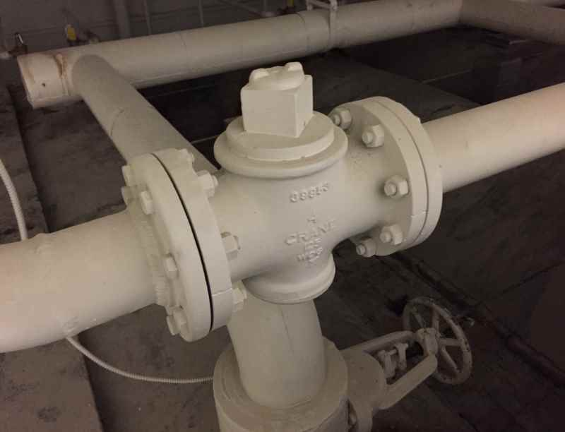
A gas smell of Mercaptan chemical was experienced around this valve indicating a possible leak. This condition should be immediately evaluated by a qualified concern by soap bubble testing all the gas piping threaded joints and any necessary corrective action completed.

I would appreciate a written response within 30 days on your plans or actions taken to address the recommendations submitted in this report. For your convenience, you may mail, fax or email your response to me.

Please note Job #: 0999-9FPZ72 on your correspondence.

We appreciate your business and the opportunity to be of service. If you have questions regarding the discussions, the content of the report, or if I can be of further assistance, please contact me. Thank you for choosing Travelers.

Sincerely,

Christian D. Morris
Senior Risk Control Consultant
781-817-8389
888-803-1522 (fax number)
cdmorris@Travelers.com
Visit the Risk Control Customer Portal

The Risk Control Customer Portal is a secure portion of our website, containing customer risk management tools. To access, visit travelers.com/riskcontrol and log in or register. If you need help registering, view our Registration Quick Guide. Once in the Portal, customers can take advantage of:

- More than 1,000 safety resources, including training opportunities, newsletters, sample safety programs and policies, checklists, and technical guides, organized by industry or topic;
- Travelers Virtual Risk ManagerSM, an online self-assessment tool that helps identify safety performance gaps and delivers a customized action plan to assist in addressing safety needs.

Reduce risk. Prevent loss. Save lives.

This report is based upon the information supplied by customer personnel and/or on the conditions and practices observed at the time of the visit. The report may not list all unsafe conditions and practices; others may exist. This report is not an endorsement of and it may not be used to endorse or promote any practices, procedures, or products. The survey activities or any recommendations in this report are designed to assist the customers named in the report in the management of their own safety activities and should not be construed as legal advice. The responsibility for making changes in the operations, procedures, or for implementing any recommendations is the customer's. All warranties are hereby disclaimed and no liabilities are assumed to any party for any damages that may arise from the use of or reliance upon information contained in this report. This report does not amend, or otherwise affect, the provisions or coverages of any insurance policy or bond issued, nor is it a representation that coverage does or does not exist for any particular claim or loss under any such policy or bond. Coverage depends on the facts and circumstances involved in the claim or loss, all applicable policy or bond provisions, and any applicable law.

Note: The visit and this letter concern the following lines of coverage: Boiler & Machinery

Location: 25 Ridgefield St
Hartford, CT 06112

0999-9FPZ72
Business Unit: HOP
SAI: 8772E8007
LocID: RW_4425469

Distribution:

Orig: via email: bazzc001@hartfordschools.org

1 email : Alicia Flanders,
Segur\H D\Inc
AMF@hdsegur.com

1 email : Dale Bonn, Travelers Insurance
DBONN@travelers.com

1 email : Matthew Forneris, Boiler Account Executive
MFORNERI@travelers.com

1 email : Lynn Pintavalle, Account Manager
LPINTAVA@travelers.com

1 email : Marcin Slupek, Account Executive
MSLUPEK@travelers.com

dDocSts Screens rProc disabled rInsPic enabled rSplitInsObj enabled rInsObj enabled rInsTBox disabled rSplitInsOther disabled rInsTbl disabled rInsTsk disabled rSplChk enabled rUpdRecs enabled rUpdDist enabled rProtect disabled rFinish enabled rSndEmail disabled

