FACT SHEET

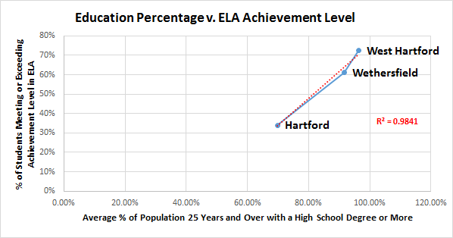

The graph to the left illustrates:

-In the **Hartford** district, 69% of the population that is 25 or older has a high school degree or more and 33% of students met or exceeded the achievement level in ELA.

-In the **Wethersfield** district, 92% of the population that is 25 or older has a high school degree or more and 60% of students me or exceeded the achievement level in ELA.

-In the **West Hartford** district, 98% of the population that is 25 or older has a high school degree or more and 72% of students met or exceeded the achievement level in ELA.

The graphs below show the percentage of the population 25 years and older with a high school degree or more versus the percentage of students meeting or exceeding achievement levels for both math and ELA.

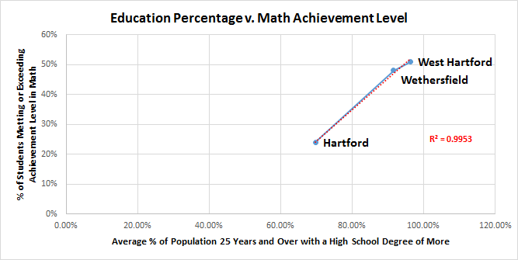

The graph to the right illustrates:

-In the Hartford district, 69% of the population that is 25 years or older has a high school degree or more and 24% of students met or exceeded achievement levels in Math.

-In the Wethersfield district, 92% of the population that is 25 years or older has a high school degree and 48% of students met or exceeded achievement levels in Math.

-In the West Hartford district, 98% of the population that is 25 years or older has a high school degree or more and 51% of students met or exceeded the achievement level in Math

FACT SHEET

**Some important statistics from the *SBAC Implementation Survey*

Images: <http://wvagainstcommoncore.wvconstitutionaladvocates.com/wp-content/uploads/2014/04/stresscomputer.jpg>

And

<http://www.chino.k12.ca.us/cms/lib8/CA01902308/Centricity/ModuleInstance/8266/testing-clipart-computer_lab.jpg>

The SBAC causes extraordinary amounts of emotional stress for students.

* 86% of teachers said that the SBAC had a negative effect on the social and emotional wellbeing of their children in their classroom
* More than ¼ of teachers said that their students became frustrated or angry while taking the test
* 60% of elementary teachers said that their students became more distraught while taking the SBAC than during any other standardized test that they had taken

*”The fact that the medium of the test administration may be interfering with students’ ability to demonstrate their knowledge of the content of the test is a major threat to the validity of the test results” –direct quote from survey*

* 20% of teachers noted that majority of their students did not exhibit computer skills to perform successfully on the test.
* 71% of teachers reported that students exhibited widely inequitable computer skills when taking the SBAC

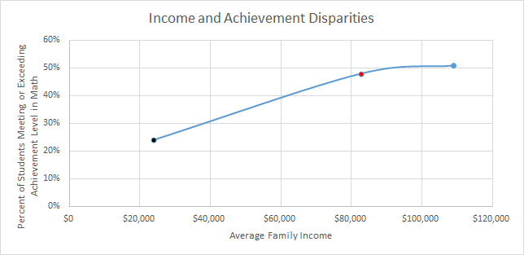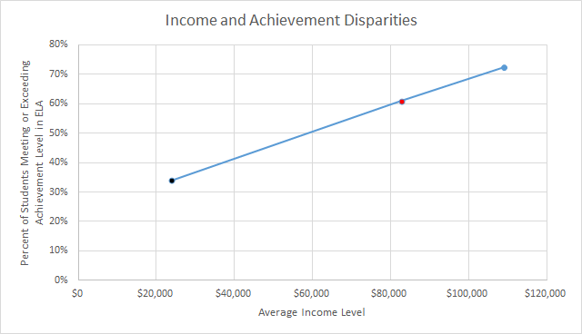

The graphs below show the average income level ($) versus the percentage of students meeting or exceeding achievement levels for both math and ELA.

FACT SHEET

The graph to the right illustrates:

-The **Hartford** district has an average income of about $23,000 and about 24% of students met or exceeded the achievement level in Math.

-The **Wethersfield** district has an average income of about $82,000 and about 48% of students met or exceeded the achievement level in Math.

-The **West Hartford** district has an average income of about $110,000 and about 51% of students met or exceeded the achievement level in Math.

The graph to the left illustrates:

-The **Hartford** district has an average income of about $23,000 and about 33% of students met or exceeded the achievement level in ELA.

-The **Wethersfield** district has an average income of about $82,000 and about 60% of students met or exceeded the achievement level in ELA.

-The **West Hartford** district has an average income of about $110,000 and about 72% of students met or exceeded the achievement level in ELA